+++ Press Release+++

POSITAL Measuring Wheels Turn Rotary Encoders into Linear Position Sensors

Hamilton, New Jersey, February 2016 – POSITAL has introduced a series of measuring wheel accessories for its IXARC family of rotary encoders. When one of these wheels is mounted on the shaft of an encoder, the result is an accurate and reliable instrument for measuring linear motion and position. “Rotary encoders do a great job of measuring rotary motion in shafts and other machine components” comments Jarrod Orszulak, Product Manager at POSITAL-FRABA Inc. “However, for many motion control systems, accurate linear positioning is the main objective. With the new measuring wheels, we have a very convenient way of making linear displacement measurements while taking advantage of the proven performance of our extensive line of rotary encoders. This is a great solution for equipment positioning tasks or for cut-to-length applications.”
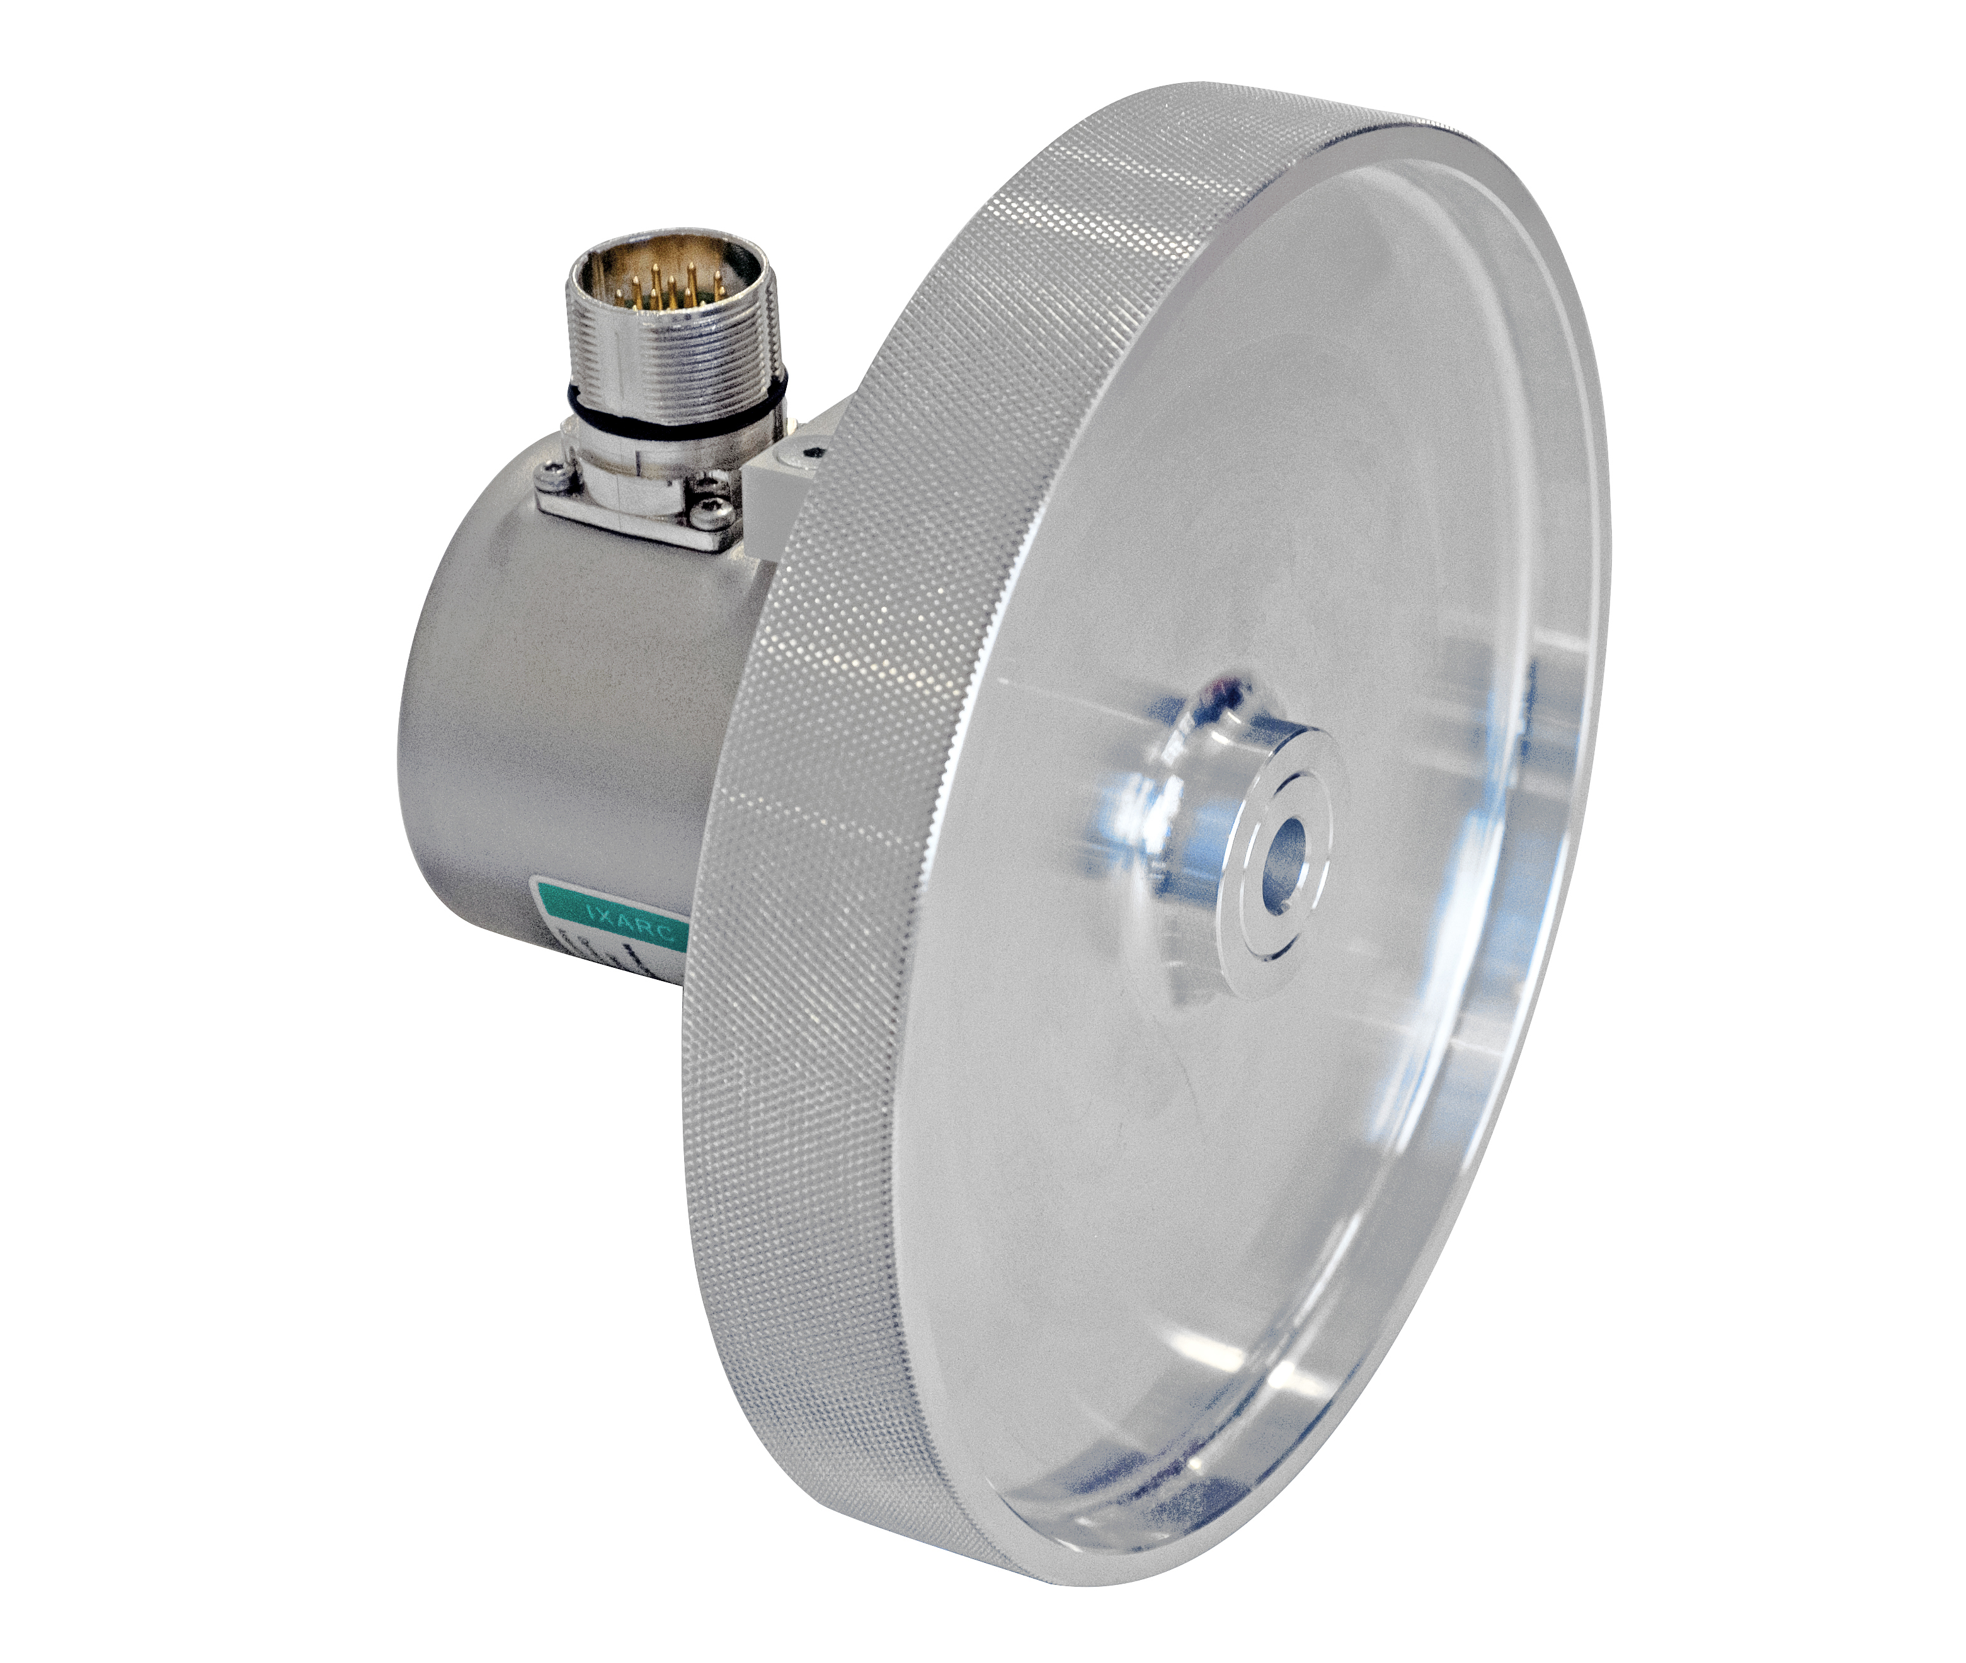
The new measuring wheels are available in circumferences of 200 mm and 500 mm. When fitted to multi-turn IXARC absolute encoders, this would translate into a linear measurement range of up to 500 kilometers! Three rim treatments are available – knurled aluminum, smooth polyurethane and textured (knobby) polyurethane – to ensure good traction between the wheel and a variety of surfaces.
Orszulak continues: “We are very excited about the combination of measuring wheels and our programmable incremental encoders. With this arrangement, a user could define exactly how many pulses the instrument would produce for a defined unit of linear motion”. IXARC programmable encoders can be easily calibrated at the job site using POSITAL’s convenient UBIFAST programming tool.
About FRABA and POSITAL
POSITAL is a supplier of advanced industrial position sensors used in a wide variety of motion control and safety systems. The company is also an innovator in product design and manufacturing processes and a pioneer of Industry 4.0 (Industrial Internet of Things/IIoT), offering customers the benefits of built-to-order products combined with the price advantages of mass-production. POSITAL is a member of the international FRABA group, whose history dates back to 1918, when its predecessor, Franz Baumgartner elektrische Apparate GmbH, was established in Cologne, Germany to manufacture relays. Since then, the company has played a trendsetting role in the development of rotary encoders, inclinometers and other sensor products. POSITAL has a gl
obal reach with subsidiaries in Europe, North America and Asia – and sales and distribution partners around the world.

Further Information
Jarrod Orszulak  FRABA Inc.  1800 East State Street, Suite 148  Hamilton, NJ 08609, USA  Phone: 609-750-8705  Fax: 609-750-8703  Jarrod.orszulak@fraba.com |  | James Tulk  PR Toolbox  126 Neville Park Blvd.  Toronto, Ontario, Canada, M4E 3P8  Phone: 416-368-6636  Mobile: 416-738-1529  jtulk@pr-toolbox.com
www.posital.com

