+++ PRESS RELEASE +++

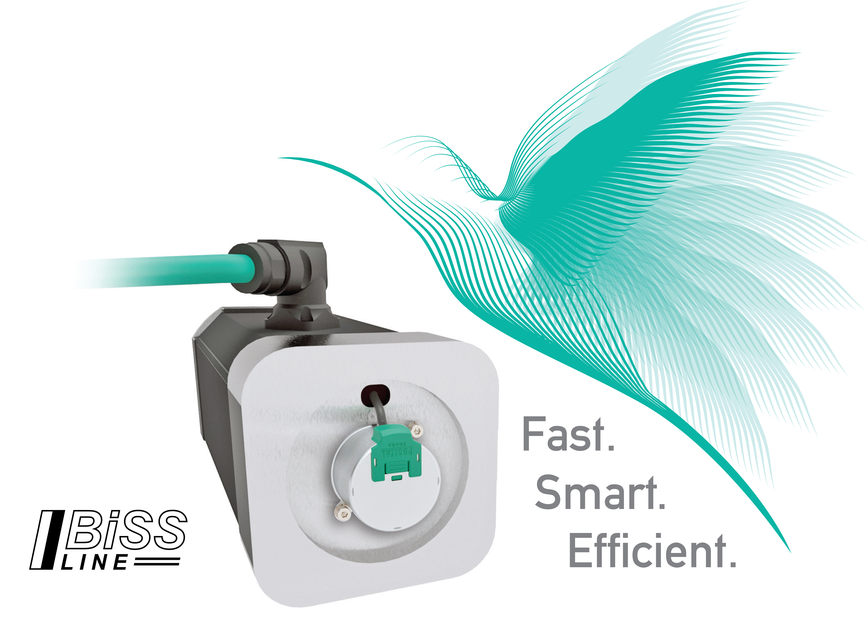
POSITAL Announces New Open Source Interfaces for
Motor Feedback Kit Encoders

Hamilton, New Jersey, November 2017 – Rotary encoder specialist POSITAL has expanded its interface offerings for its kit encoder, launched with great success last year, with support for the non-proprietary open-source BiSS Line communication protocol. This enables the practical implementation of single-cable technology, which is becoming increasingly popular with motor and robot manufacturers. POSITAL’s kit encoders, which feature 17-bit electronic resolution, bridge the gap between simple resolvers and more complex and expensive optical encoders for servomotors, robot joints and other applications where absolute rotary position feedback is required.

Single-cable technology involves the transmission of power and encoder signal in a single cable. The one-cable approach offers significant benefits for smaller motors where the placement of two connectors has always been awkward because of the lack of space. Moreover, reduced cabling reduces costs, while reducing the number of connectors reduces susceptibility to connector failures. A special feature of the BiSS Line interface is the implementation of the Forward Error Correction function (FEC), which improves availability of data communications, even with faulty cables and plug connections. "All in all, BiSS Line is an ideal interface for servomotors - and not just for cost reasons, but also for optimized performance," says Christian Fell, POSITAL’s VP of Technology. A 4-wire solution (with separate conductors for communication and power supply) or a 2-wire variant (with combined communication and instrument power supply on a wire pair), are also available, based on the same communications protocols.

From their original introduction, the new assembly kits were available with vendor-neutral digital communication interfaces such as BiSS-C or SSI for absolute measurements. "A number of optical feedback systems on the market make use of proprietary interfaces such as Hiperface or Endat, which has means an ongoing dependency on the encoder manufacturer. We deliberately took a different approach," emphasizes Fell. "We are whole-hearted advocates of open-source interfaces - and stick to them consistently." POSITAL’s commitment to the open-source strategy is affirmed by the fact that the encoder manufacturer is a founding member of the BiSS Association e.V. This new user organization, founded at the end of September, is committed to promoting the distribution of the free-of-charge BiSS family of open-source communication protocols worldwide. (http://www.biss-interface.com)

About FRABA and POSITAL
POSITAL is a supplier of advanced industrial position sensors used in a wide variety of motion control and safety systems. The company is also an innovator in product design and manufacturing processes and a pioneer of Industry 4.0 (Industrial Internet of Things/IIoT), offering customers the benefits of built-to-order products combined with the price advantages of mass-production. POSITAL is a member of the international FRABA group, whose history dates back to 1918, when its predecessor, Franz Baumgartner elektrische Apparate GmbH, was established in Cologne, Germany to manufacture relays. Since then, the company has played a trendsetting role in the development of rotary encoders, inclinometers and other sensor products. POSITAL has a global reach with subsidiaries in Europe, North America and Asia – and sales and distribution partners around the world.

Contact

Janin Halberg Martin Wendland
POSITAL-FRABA PR Toolbox
Zeppelinstr. 2 126 Neville Park Blvd.
50667 Köln Toronto, Canada
Tel.: +49 221-96213-399 Tel.: 001-416-8308797 / +49-160-99127473
janin.halberg@fraba.com mwendland@pr-toolbox.com
www.posital.de

