+++ PRESS RELEASE +++

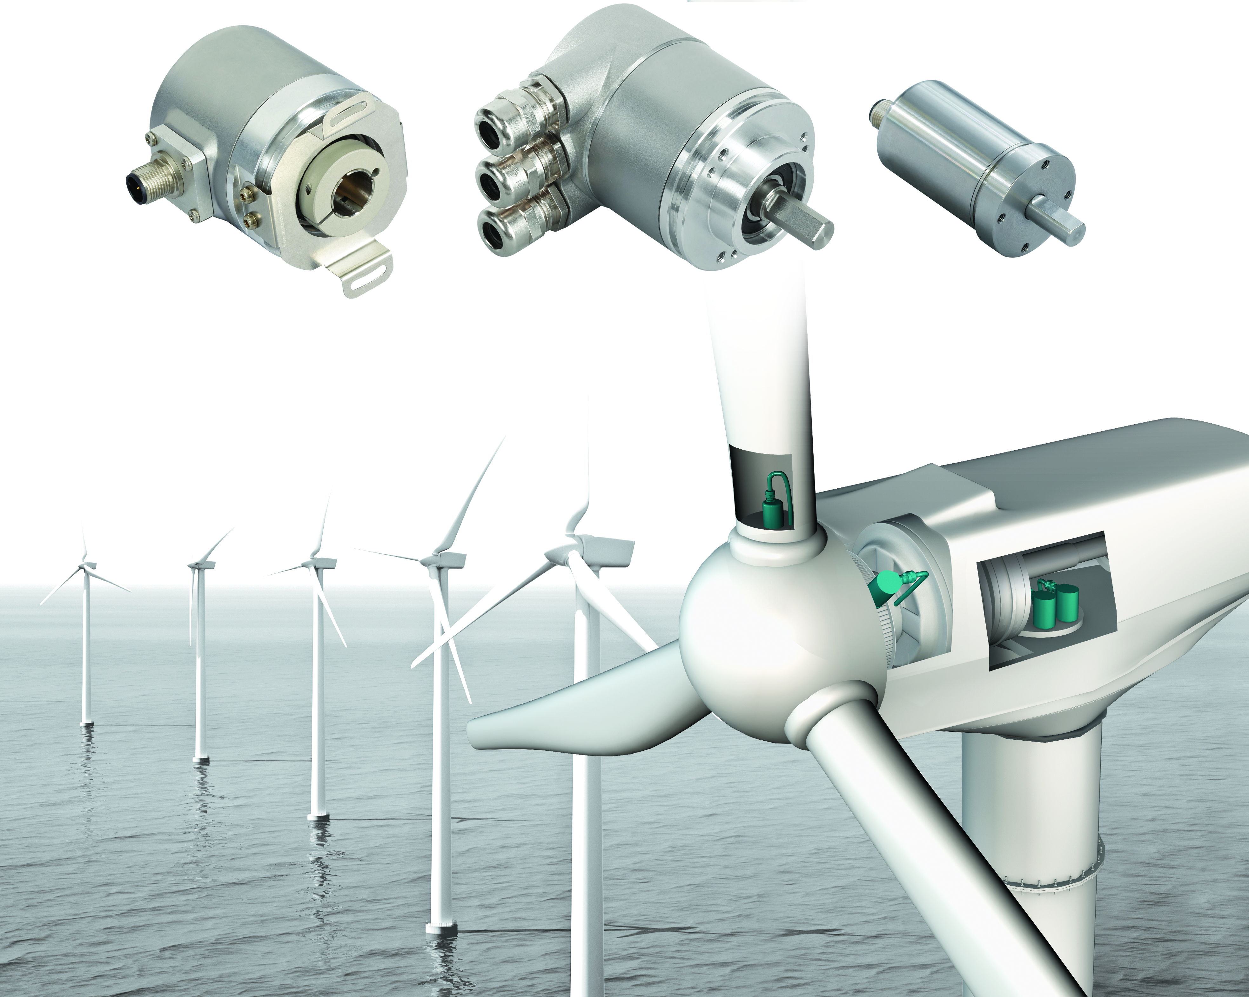

Facing a favorable wind: Robust, versatile sensors for wind turbines

Cologne/ Germany, August 2016 – There are several measuring and positioning tasks that must be handled efficiently in wind turbines: in addition to ensuring that the azimuth drives are able to keep the nacelle pointed into the wind, the tilt angle of the rotor blades must be monitored and continuously adjusted through a pitch control system. On top of that, speed control can be challenging under demanding environmental conditions. POSITAL, a provider of encoders (rotation sensors), offers an extensive one-stop range of accurate, reliable sensors that can stand up to extreme environmental conditions.

Absolute and incremental encoders

POSITAL absolute encoders always ensure reliable positioning. Unlike incremental systems, absolute encoders never require a reference check, even after power failures. In this way, they increase the safety and operational availability of wind power plants. Their excellent positioning precision also helps increase economic efficiency. Absolute encoders from POSITAL are available with a wide range of fieldbus, Ethernet and serial interfaces as well as many different mechanical models, allowing for easy integration into machines and plants.

Meanwhile, incremental encoders, which send out a series of pulse signals at a rate that is directly proportional to rotation speed, are ideal for speed control systems. Incremental rotary encoders feature a unique combination of high performance and rugged durability. They are available in a large variety and have a programming interface for maximum versatility.

Application examples

POSITAL sensors have proven themselves in many wind energy applications. For example, absolute encoders with 16 Bit maximum resolution are used to provide absolute position measurement for the azimuth control systems that adjust the orientation of the nacelle in response to changes in wind direction. In addition to high resolution, such applications also require sensors that can stand up to the mechanical loads that can be imposed when the nacelle structure is exposed to strong winds. With a shaft load capacity of up to 300 N, POSITAL encoders are one of the best options for these tasks. Robust, tried-and-tested absolute encoders ensure better reliability and operating safety, which helps users reduce downtime and the associated costs.

Magnetic absolute encoders are used to precisely determine blade angles for the pitch control system. A high level of environmental protection is a key requirement here, since extreme conditions prevail especially in offshore wind turbine parks. With durable, salt-spray resistant IP69K housings, POSITAL absolute encoders are ideal for these tough conditions. Based on an innovative magnetic technology that does away with the need for gears or batteries, the encoders are very compact and easy to install in limited spaces. Since the measuring process in these models is completely wear-free, these encoders offer long, trouble-free service lives.

Magnetic incremental encoders can provide an impressive combination of accuracy and durability for wind turbine speed control systems. POSITAL’s reliable incremental encoders are available with environmental protection ratings of up to IP69K. They can be programmed to provide up to 16,384 pulses per revolution, with a choice of Push-Pull (HTL) or RS422 (TTL) communications interfaces. Resolution and interface parameters can be set quickly and easily through the use of POSITAL’s UBIFAST programming tool. This compact and convenient device enables users to configure POSITAL incremental encoders on-site from any browser enabled device - laptops, tablets or even smart phones.

About POSITAL
POSITAL is a supplier of advanced industrial position sensors used in a wide variety of motion control and safety systems. The company is also an innovator in product design and manufacturing processes and a pioneer of Industry 4.0 (Industrial Internet of Things/IIoT), offering customers the benefits of built-to-order products combined with the price advantages of mass-production. POSITAL is a member of the international FRABA group, whose history dates back to 1918, when its predecessor, Franz Baumgartner elektrische Apparate GmbH, was established in Cologne, Germany to manufacture relays. Since then, the company has played a trendsetting role in the development of rotary encoders, inclinometers and other sensor products. POSITAL has a global reach with subsidiaries in Europe, North America and Asia – and sales and distribution partners around the world.

Press Photo (see jpg attached)

Caption: POSITAL sensors for measurement and positioning tasks in wind turbines

Note: POSITAL will exhibit at WindEnergy 2016 in Hamburg/ Germany(September 27 - 29). Visit us at Hall B 6, booth 538 (Group Stand of German State North Rhine-Westphalia/NRW).

Further Information
Janin Halberg Martin Wendland
POSITAL-FRABA PR Toolbox
Zeppelinstr. 2 126 Neville Park Blvd.
50667 Köln Toronto, Canada
Tel +49 221-96213-399 Tel 001-416-8308797
janin.halberg@fraba.com mwendland@pr-toolbox.com

www.posital.com

