+++ Press Release+++
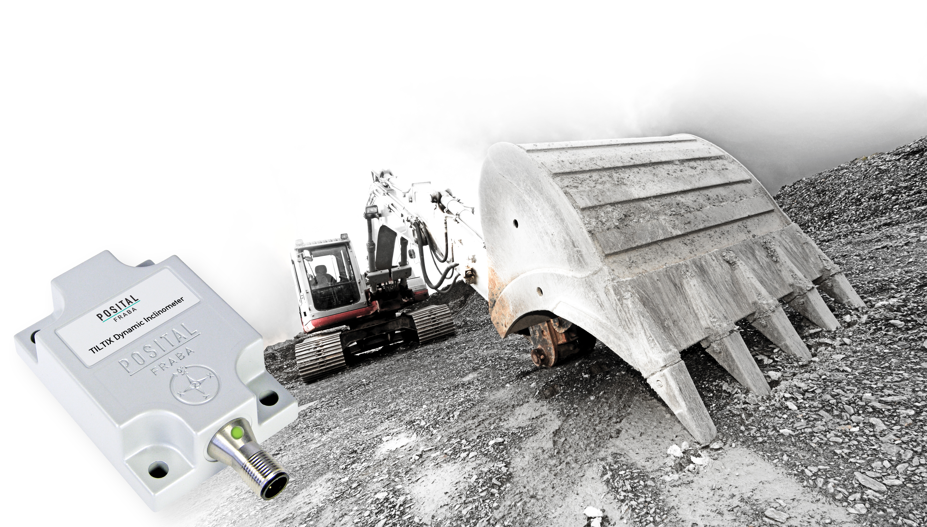
POSITAL Inclinometers with Dynamic Load Compensation
Cologne, March 2017 – POSITAL has introduced new versions of its TILTIX inclinometers that can provide reliable tilt measurement for moving equipment. These new devices use a combination of electro-mechanical gyroscopes and accelerometers to provide accurate measurements, even if the instruments are subject to strong accelerations.
POSITAL’s TILTIX inclinometers rely on monitoring the effect of gravity on a tiny mass suspended in an elastic support structure. When the device tilts, this mass will move slightly, causing a change of capacitance between the mass and the supporting structure. The tilt angle is calculated from the measured capacitances. Unfortunately, accelerations (e.g. due to rapid motion of the equipment to which the instrument is attached) will also cause the mass to shift relative to its support structure and introduce errors in the tilt measurements. POSITAL’s engineers have eliminated this problem by adding a set of electromechanical gyroscopes to the inclinometers. Signals from these gyroscopes are used to compensate for the effects of acceleration, with the result that the new dynamic TILTIX inclinometers can be used reliably on mobile equipment such as construction machinery, mining equipment, cranes and anywhere else where sudden movements, shocks and vibrations are likely to be encountered.

The new dynamic TILTIX inclinometers have a measurement range of +180° around their X-axis (pitch) and + 90°around their Y-axis (roll). This enables them to cover a full range of motions. The CANopen communications interface is currently supported, with analog, SAE J-1939 and Modbus interfaces soon to be introduced. Durable plastic or extra-rugged aluminum housings are offered.

About FRABA and POSITAL
POSITAL is a supplier of advanced industrial position sensors used in a wide variety of motion control and safety systems. The company is also an innovator in product design and manufacturing processes and a pioneer of Industry 4.0 (Industrial Internet of Things/IIoT), offering customers the benefits of built-to-order products combined with the price advantages of mass-production. POSITAL is a member of the international FRABA group, whose history dates back to 1918, when its predecessor, Franz Baumgartner elektrische Apparate GmbH, was established in Cologne, Germany to manufacture relays. Since then, the company has played a trendsetting role in the development of rotary encoders, inclinometers and other sensor products. POSITAL has a global reach with subsidiaries in Europe, North America and Asia – and sales and distribution partners around the world.

Contact
Janin Halberg Martin Wendland
POSITAL-FRABA PR Toolbox
Zeppelinstr. 2 126 Neville Park Blvd.
50667 Köln Toronto, Canada
Tel.: +49 221-96213-399 Tel.: 001-416-8308797 / +49-160-99127473
janin.halberg@fraba.com mwendland@pr-toolbox.com

www.posital.de

