Press release

New POSITAL rotary encoders combine incremental and absolute functionality

Cologne – The FRABA Group introduces new members of its IXARC family of rotary encoders that combine incremental and absolute rotation measurement capabilities in a single, compact package. Since absolute encoders provide the control system with an accurate report of the rotational angle and number of complete rotations of the encoder shaft at a specific point in time, they are an ideal solution for many machinery positioning tasks. Incremental encoders, on the other hand, provide a signal pulse every time the encoder shaft rotates by a specified angle. Their excellent dynamic response makes them a good choice for monitoring rotational speed and direction. The combination of both measurement capabilities in a single device provides control system designers with extra flexibility. Moreover, the incremental signal can be used as a “heartbeat” that confirms that the sensor is functioning normally.
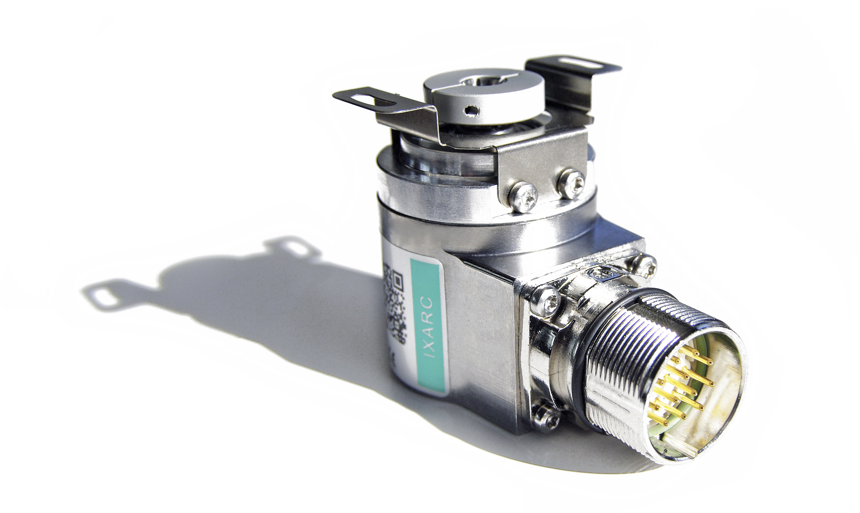
IXARC incremental + absolute rotary encoders have communications interfaces that support both modes: RS-422, HTL, or TTL for incremental readings and SSI for absolute measurements. Available multi-turn versions can count up to one million revolutions while incremental measurements have resolutions as high as 16,384 pulses per revolution. The full range of programmable options and features can be selected through the use of POSITAL’s new UBIFAST programming interface. The UBIFAST system includes a programming interface built into the encoders and a new UBIFAST configuration tool that enables users to program their devices through an easy-to-use WiFi-enabled user interface. Like other POSITAL sensors, the new IXARC incremental + absolute encoders are available with multiple options for housing size and materials, flange configuration, shaft type and diameter, connection/wiring type and level of environmental protection – up to IP69K. Available at www.posital.com, POSITAL’s online product finder tool helps users to quickly and efficiently identify products that will meet their specific requirements.

Figures: | XXX | Char.s: | 2,102
File name: | 201409033_pm_ixarc_inkr+absolut | Date: | 2014-09-19

Company background

POSITAL, a highly specialized manufacturer of absolute and incremental rotary encoders as well as inclinometers, belongs to the FRABA group which dates back to 1918, when its predecessor Franz Baumgartner elektrische Apparate GmbH, a producer of relays, was established. In 1963, the parent company introduced the first metallic brush-based absolute rotary encoders, and developed optical absolute encoders in the 1970s. Founded in the 1980s, the company’s encoder division established itself as a successful supplier for the machine building industry. In 1993, the management consultant Christian Leeser, his brother Dr. Achim Leeser, and Axel Wiemann, head of the encoder division, acquired the company and restructured it with a new management. Today, the group consists of independent companies that employ a staff of 120 at locations in Germany, Singapore, and the USA, and operate a state-of-the-art production plant in Poland. Over the last few years, POSITAL has developed various innovative products, including optical and magnetic safety encoders as well as high-resolution magnetic multi-turn encoders.

Contact:  FRABA AG  Tobias Schubert  Carlswerkstr. 13c  51063 Köln  Germany  Tel.: +49 221 / 9 62 13-0  Fax: +49 221 / 9 62 13-20  e-mail: schubert@posital.com  web: www.posital.com |  | gii die Presse-Agentur GmbH  Immanuelkirchstr. 12  10405 Berlin  Germany  Tel.: +49 30 / 53 89 65-0  Fax: +49 30 / 53 89 65-29  e-mail: info@gii.de  web: www.gii.de

