Press release

POSITAL-FRABA Incremental Rotary Sensors: Versatility, Variety and Programmability

Cologne – Industrial motion control systems come in all shapes and sizes. POSITAL-FRABA, a leading supplier of position and motion sensors, has responded to the challenges of this diverse market by offering buyers an extraordinarily wide range of choices. POSITAL rotary encoders are offered in a wide variety of mechanical features, connector types and connection interfaces. The range of options includes mounting flanges that are compatible with European, Asian and North American practices. With over a million possible choices, buyers can find variants that will fit directly into their equipment with minimal modifications. An online product finder – accessible through www.posital.com – enables customers to browse through the full range of options and retrieve the specification datasheets and CAD drawings they need, in 11 different languages. Order fulfilment is usually within two weeks, virtually anywhere in the world.
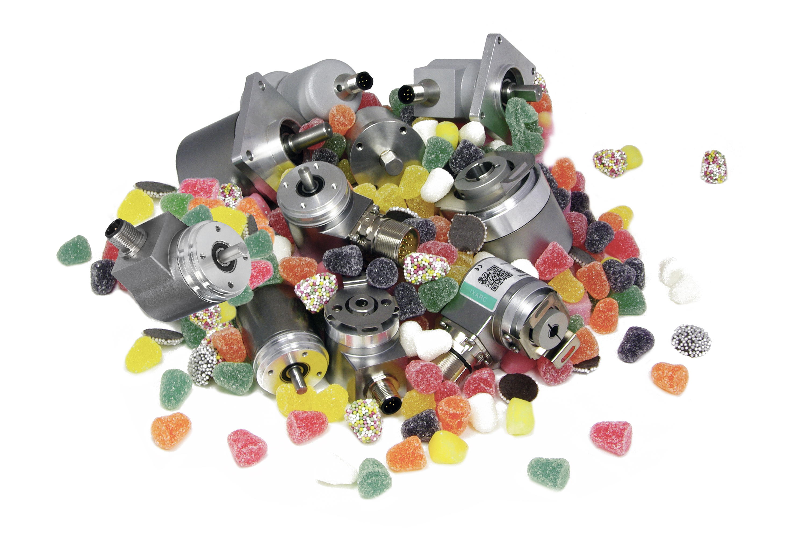
Figure: POSITAL-FRABA's incremental rotary encoders are programmable and versatile and come in a great variety of configurations.

POSITAL’s new programmable incremental rotary encoders take versatility to a new level. Resolution can be set anywhere from one to 16,384 pulses per turn in software, without changing the mechanical properties of the devices. Similarly, pulse direction and the output driver – either Push-Pull (TTL) or RS422 (TTL) – can be defined through software parameters. Changes can be made quickly using POSITAL’s easy-to-use UBIFAST programming tool. Device programmability is very significant for distributors, system integrators or machine builders since it helps them reduce inventories. Now, they can hold a relatively small stock of ‘standard’ models and set them up for specific applications on an as-needed basis. POSITAL has also introduced a unique Internet-enabled configuration management system for IXARC programmable encoders. Whenever a device is reconfigured, the operator can register the changes with POSITAL through an automatic email interface. POSITAL will update the configuration history of the device in a database maintained by the company. If a replacement part is required, this record can be accessed and used to manufacture an encoder with an identical performance profile. It could also be provided to a distributor or system integrator who could take a mechanically compatible device from their stock, enter the appropriate software parameters and deliver the completed unit directly to the end user.

Figures: | IXARC_Candy | Char.s: | 2.226
File name: | 201508025_pm_IXARC_Vielfalt_en | Date: | 2015-08-07
About POSITAL
POSITAL, a highly specialized manufacturer of absolute and incremental rotary encoders as well as inclinometers, belongs to the FRABA group which dates back to 1918, when its predecessor Franz Baumgartner elektrische Apparate GmbH, a producer of relays, was established. In 1963, the parent company introduced the first metallic brush-based absolute rotary encoders, and developed optical absolute encoders in the 1970s. Founded in the 1980s, the company’s encoder division established itself as a successful supplier for the machine building industry. In 1993, the management consultant Christian Leeser, his brother Dr. Achim Leeser, and Axel Wiemann, head of the encoder division, acquired the company and restructured it with a new management. Today, the group consists of independent companies that employ a staff of 120 at locations in Germany, Singapore, and the USA, and operate a state-of-the-art production plant in Poland. Over the last few years, POSITAL has developed various innovative products, including optical and magnetic safety encoders as well as high-resolution magnetic multi-turn encoders.

Contact:  FRABA AG  Tobias Schubert  Carlswerkstr. 13c  51063 Cologne  Germany  Tel.: +49 221 / 96 213-173  Fax: +49 221 / 96 213-20  Email: schubert@posital.com  web: www.posital.eu |  | gii die Presse-Agentur GmbH  Immanuelkirchstr. 12  10405 Berlin  Germany  Tel.: +49 30 / 538 965-0  Fax: +49 30 / 538 965-29  Email: info@gii.de  web: www.gii.de

