Press release

Thousands of POSITAL rotary encoders and inclinometers now available online at conrad.de

Cologne, Germany – POSITAL is excited to offer several thousand types of IXARC incremental and absolute rotary encoders as well as TILTIX inclinometers through electronics online retailer conrad.de. "Our cooperation with conrad.de gives the German market easy access to a broad range of our products via a major electronics retailer," says Jörg Paulus, FRABA manager for Europe, the Middle East and Asia. Following an earlier cooperation with Amazon.com, POSITAL has now partnered with a second online shop that allows for ordering thousands of unique encoders based on the completely modularized product portfolio.

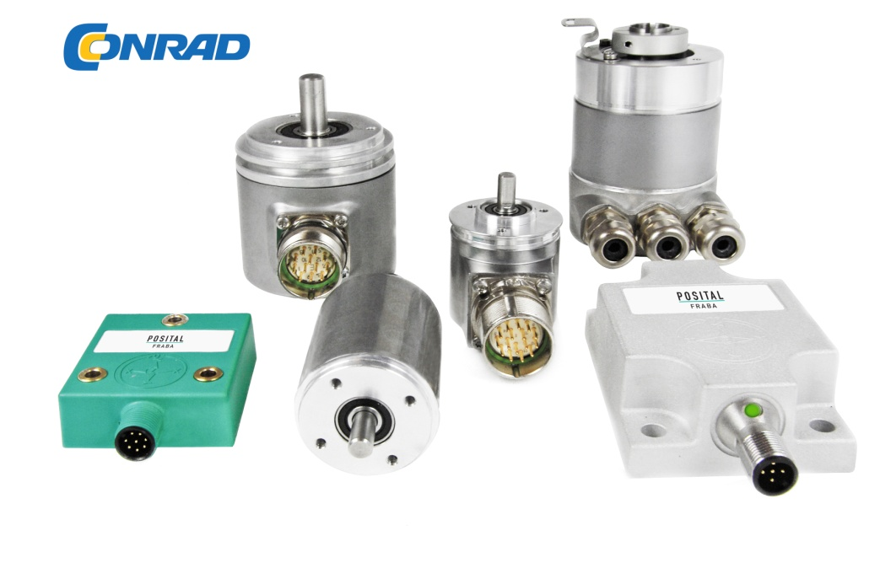
Illustration: Starting in August 2015, more than 9,000 of POSITAL's
rotary encoders and inclinometers are available through conrad.de

"Our customers can now configure and directly order one of many thousand products they may need via conrad.de – a very functional site providing a number of key user benefits, e.g. transparent pricing, quick delivery and a product finder with powerful filtering options." Upon receipt of an order, the POSITAL system automatically generates manufacturing instructions and QA specifications for assembly staff in a local production facility. Since products are based on standardized modular components, all configurations can generally be manufactured to individual requests anywhere in the world. POSITAL can thus offer an unusually wide range of customized products at mass production prices and deliver them to destinations worldwide within two weeks. POSITAL currently offers 9,000 design variants of encoders and inclinometers with 20 different interfaces (fieldbus, Industrial Ethernet protocols, analog etc.) through conrad.de – with more to follow: all 280,000 types available via the POSITAL product finder on www.posital.de will eventually become available.

Figures: | conrad | Char.s: | 1,797
File name: | 201508033_pm_conrad_en | Date: | 2015-08-13
About POSITAL
POSITAL, a highly specialized manufacturer of absolute and incremental rotary encoders as well as inclinometers, belongs to the FRABA group which dates back to 1918, when its predecessor Franz Baumgartner elektrische Apparate GmbH, a producer of relays, was established. In 1963, the parent company introduced the first metallic brush-based absolute rotary encoders, and developed optical absolute encoders in the 1970s. Founded in the 1980s, the company’s encoder division established itself as a successful supplier for the machine building industry. In 1993, the management consultant Christian Leeser, his brother Dr. Achim Leeser, and Axel Wiemann, head of the encoder division, acquired the company and restructured it with a new management. Today, the group consists of independent companies that employ a staff of 120 at locations in Germany, Singapore, and the USA, and operate a state-of-the-art production plant in Poland. Over the last few years, POSITAL has developed various innovative products, including optical and magnetic safety encoders as well as high-resolution magnetic multi-turn encoders.

Contact:  - FRABA AG  Jörg Paulus  Carlswerkstr. 13c  51063 Köln  Germany  Tel.: +49 221 / 96 213-16  Fax: +49 221 / 96 213-20  Email: paulus@posital.com  web: www.posital.eu |  | gii die Presse-Agentur GmbH  Immanuelkirchstr. 12  10405 Berlin  Germany  Tel.: +49 30 / 538 965-0  Fax: +49 30 / 538 965-29  Email: info@gii.de  web: www.gii.de

