+++ PRESS RELEASE +++

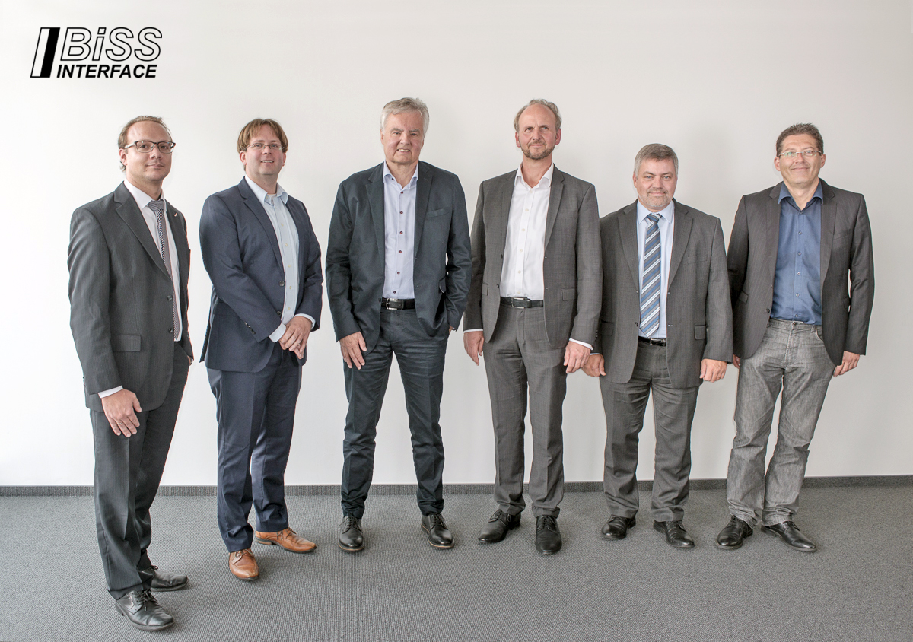
POSITAL Participates in Launch of BiSS Association e.V.
New Organization promotes No-Charge, Open Source Interface Technology for Industrial Control Systems
<Location<Date> POSITAL FRABA has announced that it is participating as a founding member of the BiSS Association e.V., a new organization dedicated to encouraging the use of the BiSS family of open-source industrial communications protocols. (http://biss-interface.com/)
BiSS communications protocols were developed by the German company iC-Haus GmbH as an efficient and feature-rich digital interface for communications between industrial sensors, actuators and control devices. iC-Haus is also the source of ASIC chips that support the implementation of this interface in industrial devices such as sensors, actuators and controllers.
The BiSS interface is hardware compatible with the well-established SSI (Serial Synchronous Interface) digital interface, but offers significant enhancements. BiSS supports continuous (real-time) communications between controllers and sensors. BiSS Safety offers functionality for critical systems where safety ratings up to SIL 3 are required. Applications of the BiSS interface include manufacturing robotics, motor feedback, servo drives & motion control, position encoders and CNC drives.
An important new development is BiSS Line – an implementation of BiSS protocols that can be deployed in a single cable configuration and features forward error correction (FEC). This makes BiSS Line an ideal interface for servomotors where the single cable feature offers a significant reduction in wiring system complexity.
BiSS is offered as an open source interface. There are no licensing fees for either manufacturers of BiSS-enabled devices or their customers. BiSS Association e.V. is autorized to grant free-of-charge BiSS licenses to device manufacturers and BiSS users. The agreement defines rights and duties to make use of associated patents and trademarks for BiSS held by iC-Haus.
The new BiSS Association organization aims to expand the use of BiSS technology throughout the world. It will also provide a communications platform for technical standards and cooperative marketing initiatives. POSITAL FRABA’S Jörg Paulus has been appointed Vice Chairman of the association, joining Dr. Heiner Flocke of iC-Haus (Chairman) and Alexander Ehnert of Hengstler GmbH (Treasurer). Membership in the BiSS Association is open to all companies and institutions. Members can participate in the development and promotion of this exciting new interface. Access to BiSS technologies and licensing arrangements are open to members and non-members alike.

About FRABA and POSITAL
POSITAL is a supplier of advanced industrial position sensors used in a wide variety of motion control and safety systems. The company is also an innovator in product design and manufacturing processes and a pioneer of Industry 4.0 (Industrial Internet of Things/IIoT), offering customers the benefits of built-to-order products combined with the price advantages of mass-production. POSITAL is a member of the international FRABA group, whose history dates back to 1918, when its predecessor, Franz Baumgartner elektrische Apparate GmbH, was established in Cologne, Germany to manufacture relays. Since then, the company has played a trendsetting role in the development of rotary encoders, inclinometers and other sensor products. POSITAL has a global reach with subsidiaries in Europe, North America and Asia – and sales and distribution partners around the world.

Contact

Janin Halberg Martin Wendland
POSITAL-FRABA PR Toolbox
Zeppelinstr. 2 126 Neville Park Blvd.
50667 Köln Toronto, Canada
Tel.: +49 221-96213-399 Tel.: 001-416-8308797 / +49-160-99127473
janin.halberg@fraba.com mwendland@pr-toolbox.com
www.posital.de

