+++ PRESS RELEASE +++

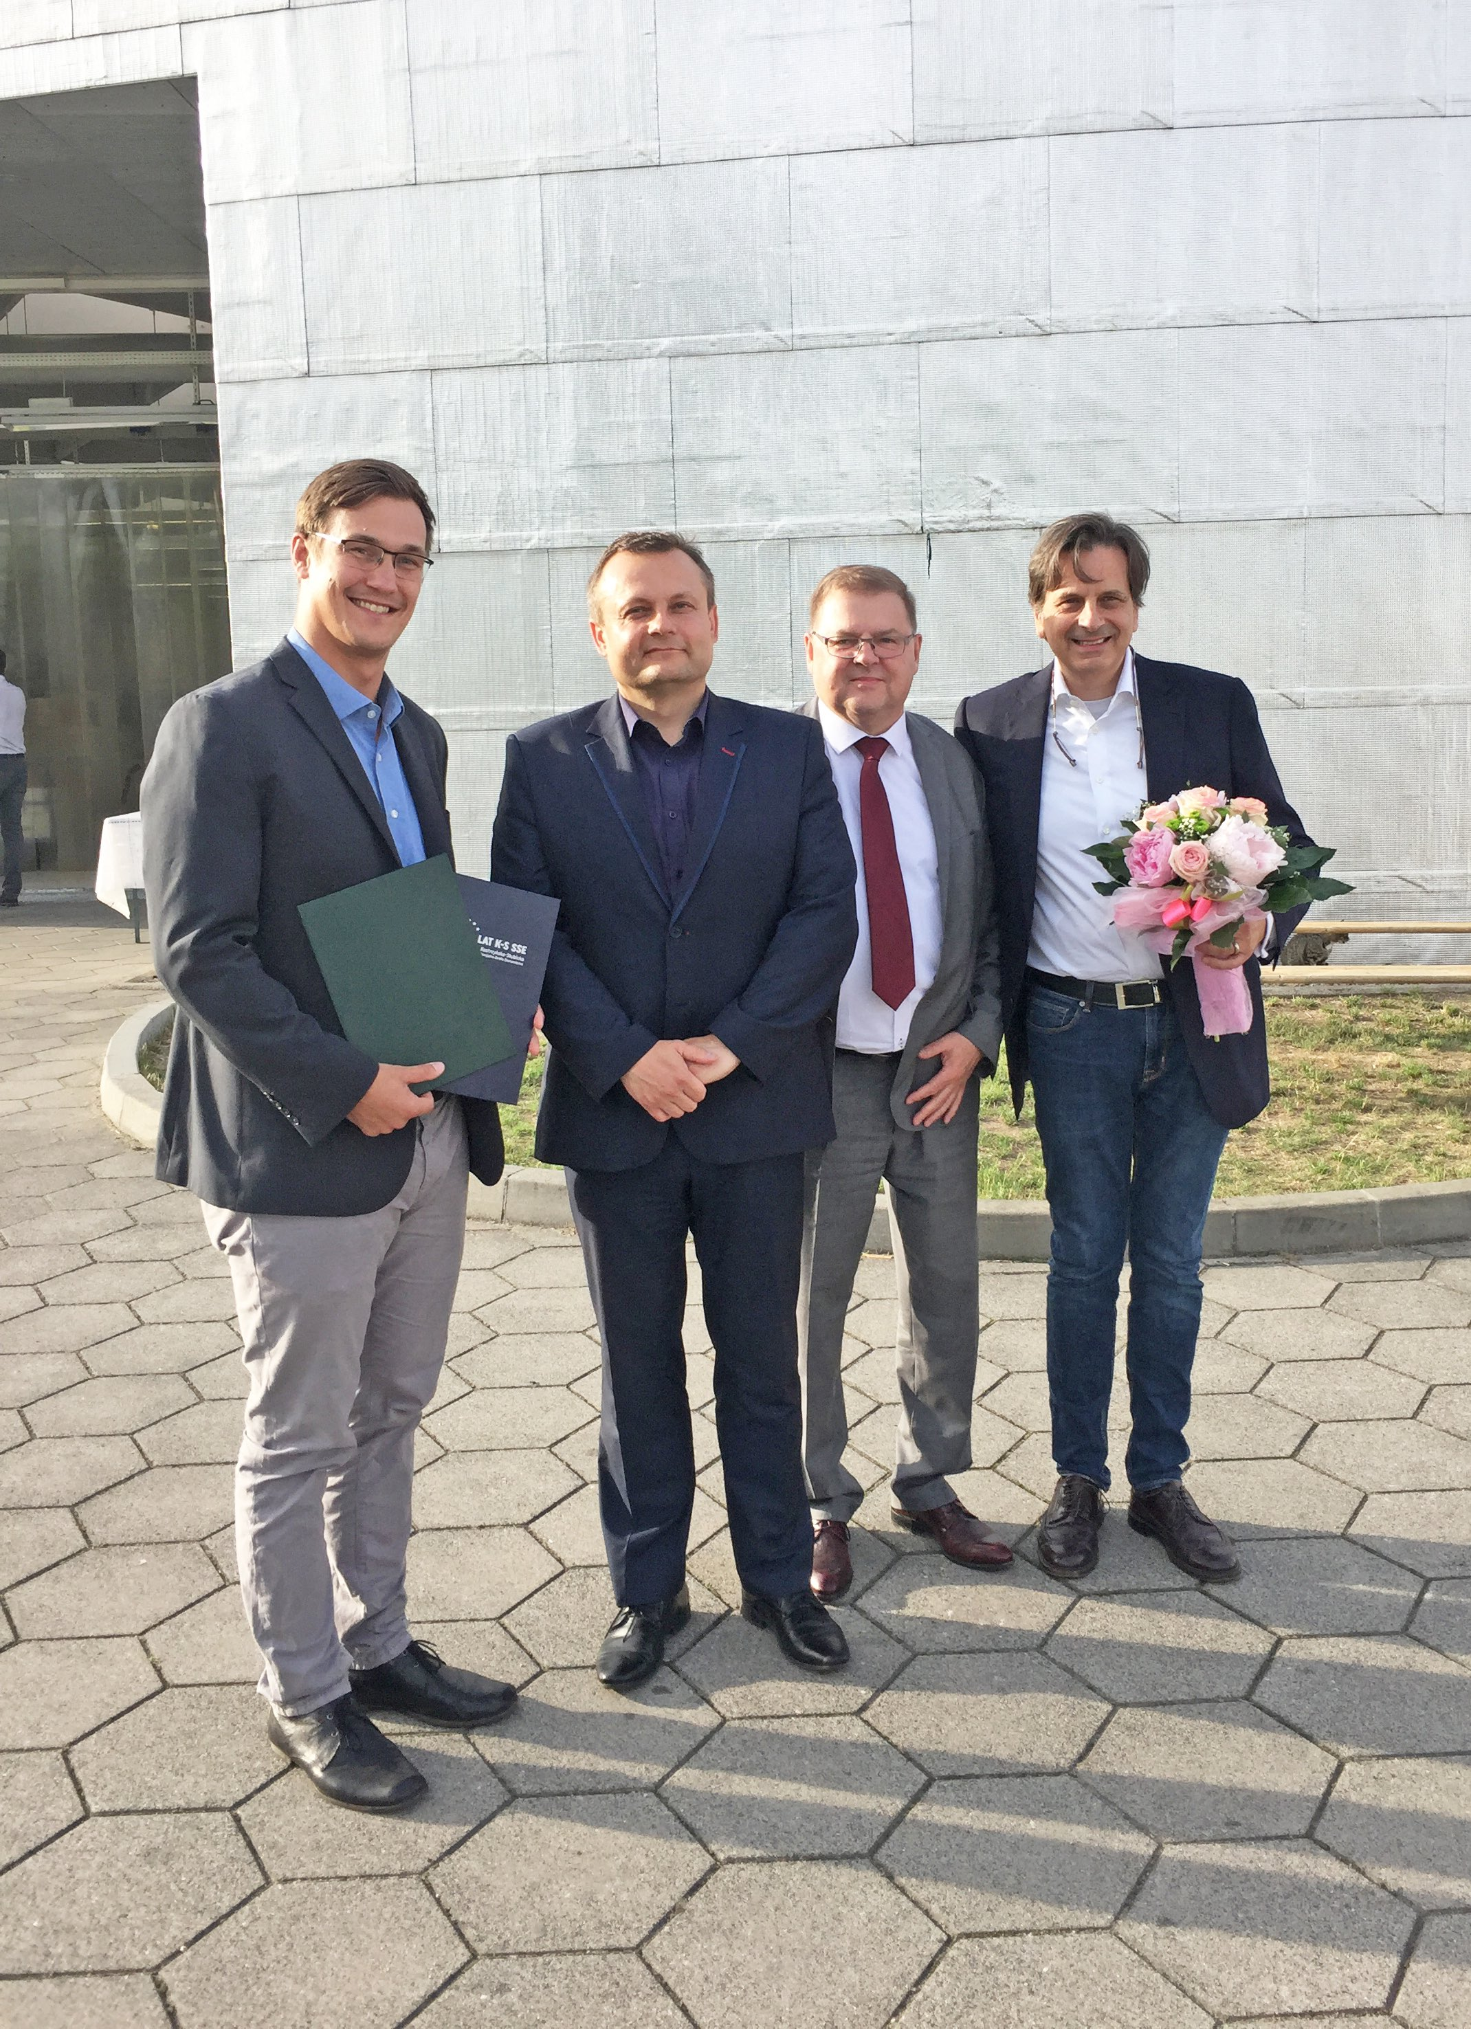

POSITAL-FRABA’s Innovative Sensor Production Facility Celebrates Its 10th Anniversary

"Mass Customization" processes successfully implemented

Slubice, Poland, August 2017 – The International FRABA Group’s main production facility, located in Slubice, Poland, has been in operation for ten years. The factory, which has been recognized for its striking architecture, was designed from the outset for small-batch/high variability production of precision industrial position and motion sensors. “The POSITAL encoders and tilt sensors we manufacture are used in an enormous range of applications,” explains Christian Leeser, CEO of the FRABA Group. “Meeting the needs of this very diverse market means that we have to be able to produce a correspondingly enormous range of product variants. Our answer has been to develop a process we call mass customization.” The sensors built at the Slubice facility are modular in design, assembled from standardized components and sub-assemblies. Customers can specify the performance characteristics, mechanical features communications interfaces etc. that they need and have the appropriate products built on demand. Leeser continues “Our average order size is 1.8. Our ability to respond to this demand in as little as 24 hours shows that our model of high variability/low batch size manufacturing has been a success. We have delivered over 500,000 units since 2007, and with ramped up production we expect to reach the one million mark within a year or two.”
The 10th anniversary of the Slubice facility was marked by a celebration attended by FRABA employees and officials from the town of Slubice and the nearby Kostrzyn industrial zone, fifty miles east of Berlin on the German-Polish border. "Slubice has been a good location for us” comments Paul Schmitz, who is responsible for the manufacturing and logistical processes in the digital factory. "We are only a few minutes away from the highway, which makes it possible to reach Berlin-Schönefeld Airport in less than an hour." Production in Poland has replaced traditional production at FRABA's Cologne headquarters. All the product and process data are stored on a company-owned cloud. The advanced computerized production control system integrates ongoing QA checks, guaranteeing a high product quality. "In Slubice, we have once again raised the bar for quality," says Leeser. "Even higher than what we had been able to achieve in Cologne with teams of highly skilled technicians. The bottom line is that we have not only become faster and cheaper, but also improved - all in the interests of our customers. "

About FRABA and POSITAL
POSITAL is a supplier of advanced industrial position sensors used in a wide variety of motion control and safety systems. The company is also an innovator in product design and manufacturing processes and a pioneer of Industry 4.0 (Industrial Internet of Things/IIoT), offering customers the benefits of built-to-order products combined with the price advantages of mass-production. POSITAL is a member of the international FRABA group, whose history dates back to 1918, when its predecessor, Franz Baumgartner elektrische Apparate GmbH, was established in Cologne, Germany to manufacture relays. Since then, the company has played a trendsetting role in the development of rotary encoders, inclinometers and other sensor products. POSITAL has a global reach with subsidiaries in Europe, North America and Asia – and sales and distribution partners around the world.

Contact

Janin Halberg Martin Wendland
POSITAL-FRABA PR Toolbox
Zeppelinstr. 2 126 Neville Park Blvd.
50667 Köln Toronto, Canada
Tel.: +49 221-96213-399 Tel.: 001-416-8308797 / +49-160-99127473
janin.halberg@fraba.com mwendland@pr-toolbox.com
www.posital.de

